**Python Programming**

**31/01/2024**

**HISTORY**

**1989 – implementation Started.**

**1991 - python was Released.(Invented by guido van Rossum )(took name from Monty python fliying circus).**

**Cd desktop**

**cd oct python**

**py first.py**

1. **Python is the most concise programming programming language.**
2. **Python is dynamically types programming language.**

**Interactive mode(line by line execution like chatting)**

**Scripting mode(file execution)**

**#Style of Python Programming language:**

* **Scripting way**
* **Procedural way**
* **Object oriented way of writing.**

**#data types**

**#basic dt of python:**

* **Int 1234566**
* **Float 9366926354.983798**
* **Bool true/false**
* **Complex 10+1j/12j+0**
* **Str ‘mahi’,”mahi”,”””mahi”””**

**#Data Structures of python:**

* **List []**
* **Tuple ()**
* **Set {}**
* **Dic {key,value}**

**Types of Type Casting:**

1. **Implicite type casting:**

**Is done by python internally**

1. **Explict Type casting:**

**Is done by programmer using built-in functions.**

* **Int()**
* **float()**
* **bool()**
* **complex()**
* **str()**

[**https://kodnesttechnologies-my.sharepoint.com/:w:/g/personal/priyamallikarjun_kodnest_com/ERCEhj2uAIJAirgsAsOkJLABgOeS4tbLkYA61VflIBRC8w?e=RQuQXK**](https://kodnesttechnologies-my.sharepoint.com/:w:/g/personal/priyamallikarjun_kodnest_com/ERCEhj2uAIJAirgsAsOkJLABgOeS4tbLkYA61VflIBRC8w?e=RQuQXK)

**1/2/2024**

**Impllict type casting:**



**Ex:**

**a=10**

**b=5**



**type(a/b) -> float #2.0**

**type(a//b) ->int #2**



**#Advance Data Types:**

* list []
* tupe ()
* set []
* dic {}

List:

#creation of list-> li=[1,2,3,4,5,6] #Homogeneous data

Li=[1,2,’hi’,4+3j,1.2,True] #heterogeneous data is also allowed

1. Lists are mutable (changes made are reflected in original data)
2. List allows duplicate values.
3. List is ordered collection of data.

#checking length of list

**len(li)**

#adding element in list

**li.append(20)** #it will add in end of the list.

#extend(): used to add multiple values

**li.extend([600,700])** # Li=[1,2,’hi’,4+3j,1.2,True,20,600,700]

**li.extend(l2)** #adding l2 in li

#finding index of list

**li.index(20) #6**

**#methods to remove element or by index:**

**li.remove(600)** # removes particular element,it will always remove first occurrence of element.

**li.pop()** #removes last value

**li.pop(3)** #removes 3rd index value

**del li[2]** #removes second index item.

**del li** # deletes entire li or structure

**li.clear()** #deletes data in list but structure is present(empty list will be present



Ex:

Li=[1,2,3,4,6]

Li_new=li

Print(li_new) #1,2,3,4,6



li.append(5)

Print(li) #1,2,3,4,6,5

Print(li_new) #1,2,3,4,6,5 # = operator doest create new object rather point to same oblect.



Ex:

Ex:

Li=[1,2,3,4,6]

Li_new=list(li) # new object will created

Print(li_new) #1,2,3,4,6



li.append(5)

Print(li) #1,2,3,4,6,5

Print(li_new) #1,2,3,4,6



#reverse: will reverse the original copy but doest return anything

Li=[1,2,3]

// Print(li.reverse()) # none

li.reverse()

print(li) #3,2,1

#sort:

Li=[1,6,2,3]

// Print(li.sort()) # none

li.sort()

print(li) #1,2,3,6

**sort and printing in descending order:**

li.sort(reverse=True)

li=[1, 2, 3, 4, 200, 500, 1000]

**insert(): used to insert value at any index**

li.insert(2,30)

print(li) #[1, 2, 30, 3, 4, 200, 500, 1000]

**tuple():**

**tup=(10,20,30,40)**

* **It is an ordered collection of data**
* **We can store duplicate values**
* **Tuple stores homogeneous as well as heterogeneous type of data.**
* **Tuples are immutable.**
* **Concatiation is possible.**

**Ex:**

**Tup=(1,2,3,4)**

**Tup.append(5) #error**

**Tup.remove(2) #error**

**Tup1=(6,7)**

**Tup=tup+tup1 #(1,2,3,4,6,7)**

**Methods in tuple: min(),max(),index(),count(),tuple().**

**Set:**

1. **Set is an unordered collection of data.**
2. **In set we cannt store duplicate values.**
3. **In set we can store homogeneous as well as heterogeneous data**
4. **It doesn’t support indexing**
5. **Set is mutable**

**S1={10,20,30,40}**

**Print(s1) #10,40,20,30**

**S1.add(50)**

**Print(s1) #50,10,30,20,40**

**S1.pop() #eror**

**S1.remove(50)**

**Print(s1) #10,30,20,40**

**Dic {key:value}:**

1. **In dict we can store homogeneous as well as heterogeneous type of data.**
2. **Dic are ordered collection of data.**
3. **Dict allows to store duplicate values for the keys.**

**Methods: update(),keys(),values(),items()**

**Control Constructs:**

Conditional:

1. If:

Ex:

age=20

if(age>18):

print('valid')

1. If else:

Ex:

age=20

if(age>18):

print('valid')

else:

print('invalid')

1. Elif:

Ex:

sal=int(input('enter sal:'))

enter sal:555

if(sal<=300):

print('tax:',sal//100*4)

elif(sal>300 and sal<=500):

print('tax:',sal//100*8)

else:

print('tax:',sal//100*12)

Looping:

1. For
2. While

Jumping:

1. Break
2. Continue

**Membership operator:** in, not in

2/02/2024

l=list(range(1,11))

l

[1, 2, 3, 4, 5, 6, 7, 8, 9, 10]

Ex:

for i in range(5,-7,-2):

print(i)

5

3

1

-1

-3

-5

**Formated string pattern:**

my=[]

eve=[]

c=int(input('Enter the size of list: '))

Enter the size of list: 5

for i in range(c):

ele=int(input(f'enter the value at{i} index: '))

my.append(ele)

if(ele%2==0):

eve.append(ele)

enter the value at0 index: 2

enter the value at1 index: 5

enter the value at2 index: 6

enter the value at3 index: 8

enter the value at4 index: 9

my

[2, 5, 6, 8, 9]

eve

[2, 6, 8]

**#eval():**

**print(eval('1+2+3')) 🡪6**

**eval('10,20,30') 🡪(10, 20, 30)**

**list(eval('10,20,30')) 🡪[10, 20, 30]**

**#while:**

**#list comprehrnsion**

**M=[12,3,5,6,7]**

**Sq=[i**2 for I in m] #[144,9,25,36,49]**

**Ev=[I for I in m if i%2==0]**

**Ev #[12,6]**

**ll=[int(x) for x in input().split(' ')]**

**6 1 8 6**

**ll #[6, 1, 8, 6]**

**#Strings**

**Methods: .upper(),.lower(),.capitalize(),.title(),.split()**

**Comparision of Strings:**

**Case 1:**

s=’Mahi’

c=’Mahi’

if(s==c):

print('Equal') o/p: Equal

else:

print('not equal')

if(id(s)==id(c)):

print('ids are equal') o/p:ids are equal

else:

print('ids are not equal')

**Case 2:**

s='Mahi'

c='Mahi'

if(s==c):

print('Equal') 0/p:Equal

else:

print('not equal')

s=s.upper()

c=c.upper()

if(id(s)==id(c)):

print('ids are equal')

else:

print('ids are not equal') o/p: ids are not equal

String interning is the process of sharing the same memory location or reference for multiple variables with the same string value, it is the process which ensure that a single character object should be present in the memory.

**How string interning works?**

* When a string is created in a program the interpreter checks if the same string value already exists in memory.
* if the string value already present the interpreter re uses the existing memory location instead of creating new obj.
* If string value is unique a new memory loc is allocated for it.

**Formate method:**

N=’mahesh’

Age=23

Print(‘my name is {} ,and age is {}’.format(n,age))

Print(f’my name is{n} , and age is {age}’)

Ex 2:

S=”{} is my friend, and his age is{}”.formate(n,age)

Print(s)

**Object Orientation:**

orientation principiles:

1. The real world or project is collection of object
2. Every obj is usefull and there is no usless obj.
3. Every obj is in constant interaction with each other.
4. Every obj belongs to a type(class).Type doesn’t exist in reality but obj exists.

**Pillars of oops:**

1. **Inheritance.**
2. **Encapsulation.**
3. **Polymorphism.**
4. **Abstraction.**

**Object creation in python and envoking the member function of the class:**

Example:

class Employee:

def __init__(self,name,age):

self.name=name

self.age=age

def work(self):

print('employee is working');

def paly(self):

print('employee is playing');

s1=Employee('mahi',12)

s2=Employee('.

.

.mahesh',23)

print(s1.name,s1.age)

print(s2.name,s2.age)

s1.work()

s2.paly()

programming on list comprehension:

enumerate function:

myl=[10,20,30]

for ind,ele in enumerate(myl):

print(f’elenent is {ele} and index is {ind}’)

bisect:

import bisect

bisect.insort(my,tar)

Main Method in python:

**Local,static,instance variables:**

**class Demo:**

**x=1000 #static/class**

**def __init__(self):**

**print('inside constructor');**

**self.name='mahi' #instance**

**print(Demo.x)**

**def disp(self):**

**print('inside disp')**

**a=500 #local**

**print(Demo.x)**

**d1=Demo()**

**print(d1.x)**

**d2=Demo()**

**print(d2.x)**

**Method Overloading in python:**

**Acess specifiers:**

**Public: a def display():**

**Protected: _a def _display:**

**Private: __a def __display():**

**Name Mangaling:**

* **Is the process of providing new name for the private variables of the class.**
* **The new name will be provided in the formate of:’_className__varriableName.’**
* **By this private variable can be accessed in child class also as well as another non child class.**

**class Demo6:**

**def __init__(self):**

**self.__x=10**

**def display(self):**

**print(self.__x)**

**d5=Demo6()**

**print(d5._Demo6__x)**

**#Inheritance**

**Inheritance is the process of acquiring the properties of one class to another class.**

**Types of Inheritance:**

1. **Single inheritance**
2. **hierarchical inheritance**
3. **Multil level inheritance**
4. **Multiple inheritance**

**Diagrammatic representation of all the above types of inheritance:**

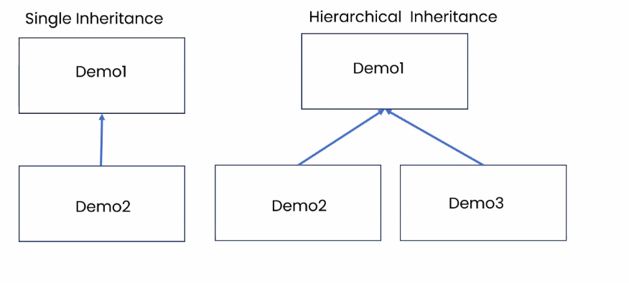

**Examples of all the types of inheritance:**

**1 single inheritance:**

**class Demo:**

**def __init__(self):**

**self.x=100**

**def disp(self):**

**print('single inheritance')**

**class Demo1(Demo):**

**pass**

**d2=Demo1()**

**d2.disp()**

**print(d2.x)**

**2.hierarchical inheritance**

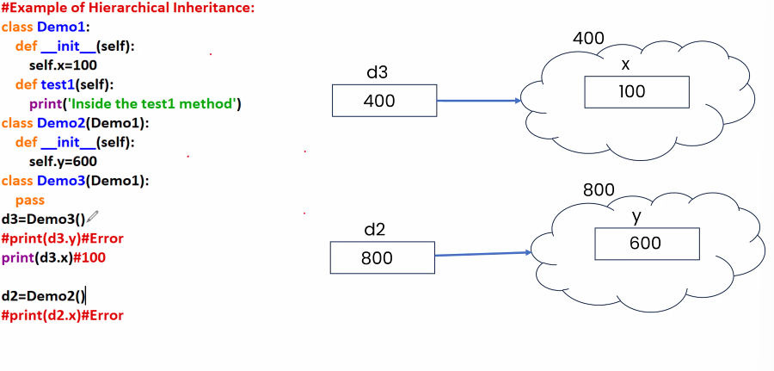

* In the above example when we are creating an obj for demo3 class then the parent class constructor of demo3 will be invoked because demo3 class doesn’t have any constructor.
* When we are creating an obj for demo2 class ,then demo2 class constructor will be called. If demo2 class doesn’t have the constructor then his parent class constructor will be called automatically.

3.Multilevel inheritance

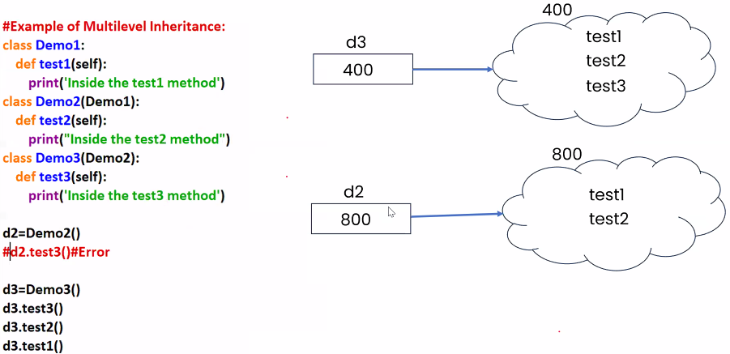

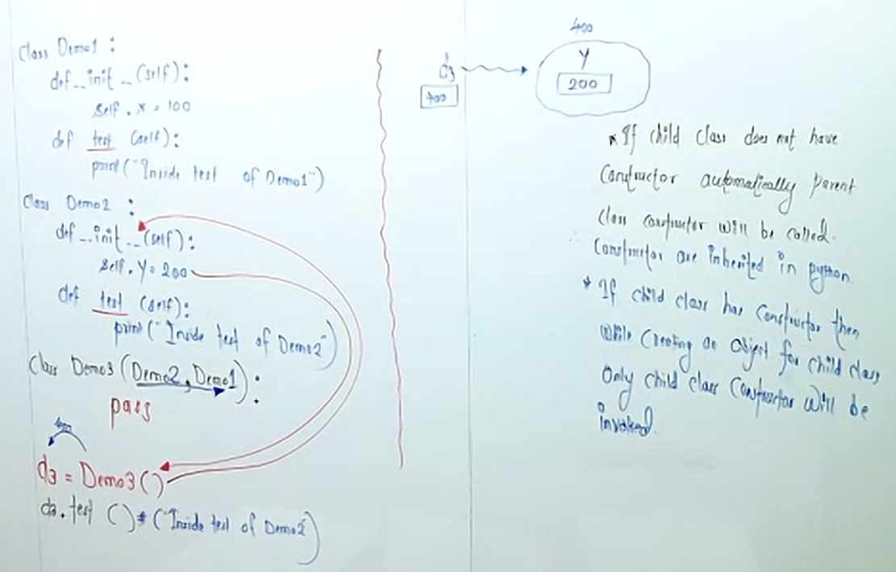

Mro(): used to know order of exection in inheritance

Classname.mro()

#[<class '__main__.Demo3'>, <class '__main__.Demo2'>, <class '__main__.Demo1'>, <class 'object'>]

Super Method in python: 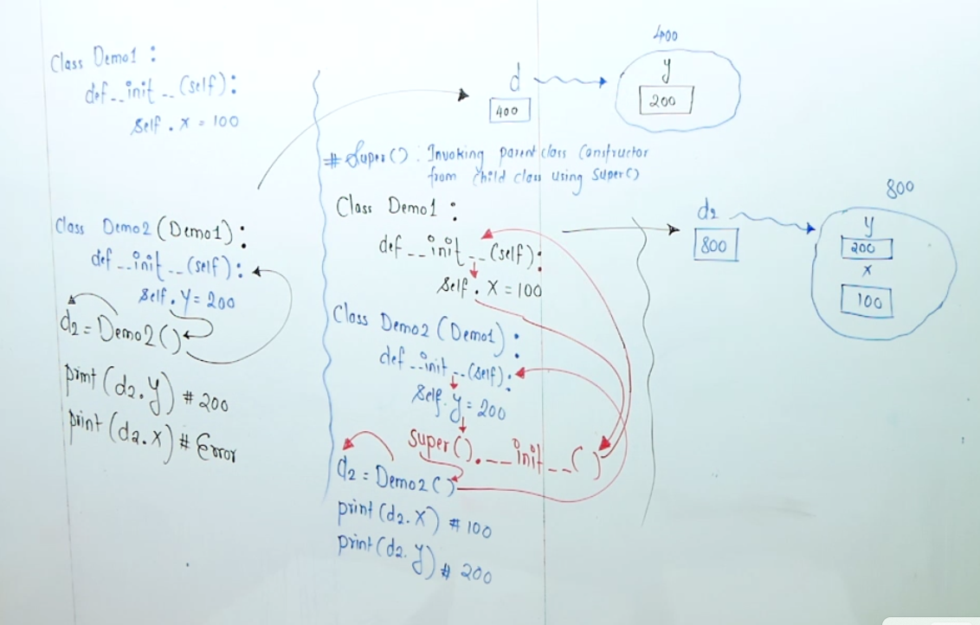

Constructor chaining is the process of calling one constructor from one constructor . in the same way Method chainning can be achieved using super().

Super().methodname

Exm:

Super.__init__()

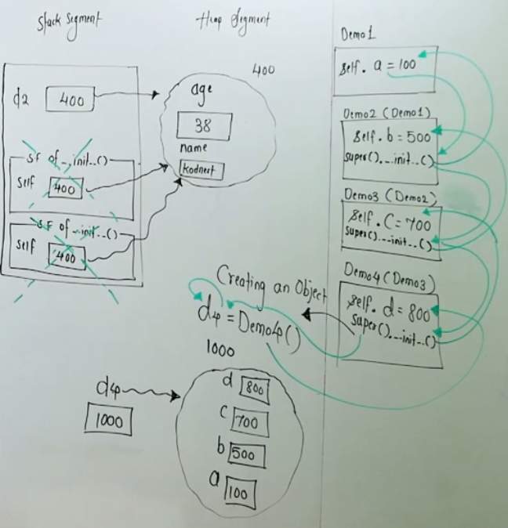

**Understanding diff between inherited ,overridden snd specialized methods:**

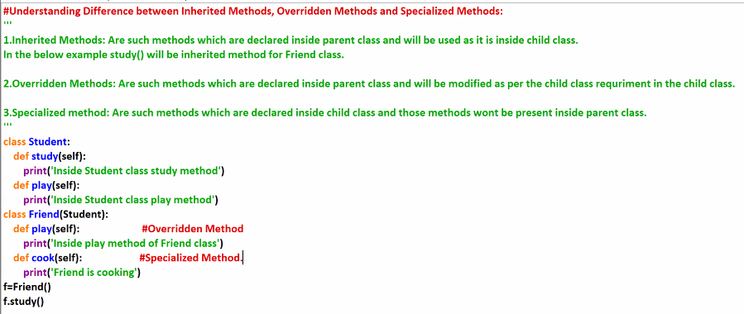

**#understanding of Dunder(double underscore)methods/magic methods:**

* **Dunder methods/magic methods are such methods which has prefix as ‘__’(doble under score) and suffix as __(double underscore) are called as dunder methods/magic methods.**
* **These methods can be called as magic methods because as a programmer we no need to call these methods rather these methods will be called automatically.tt**

**Ex:**

**__init__()**

**__str__()**

**__add__()**

**#printing an object reference:**

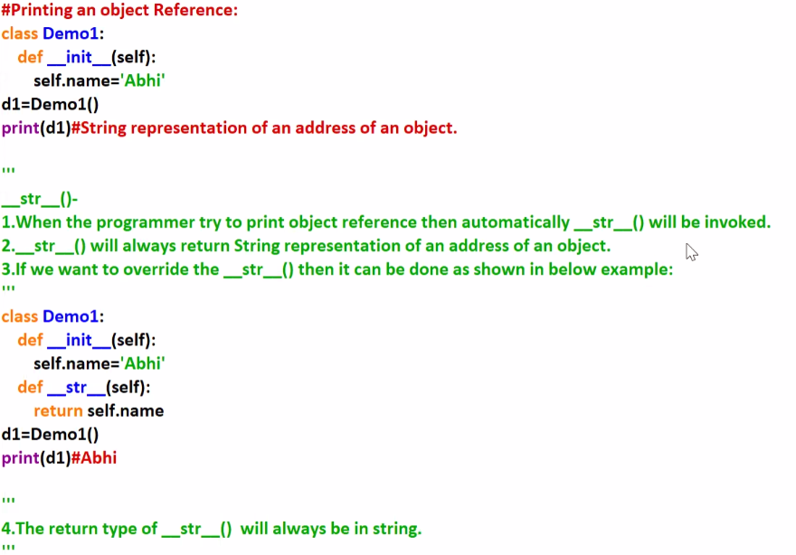

**#operator overriding in python: operator overloading**

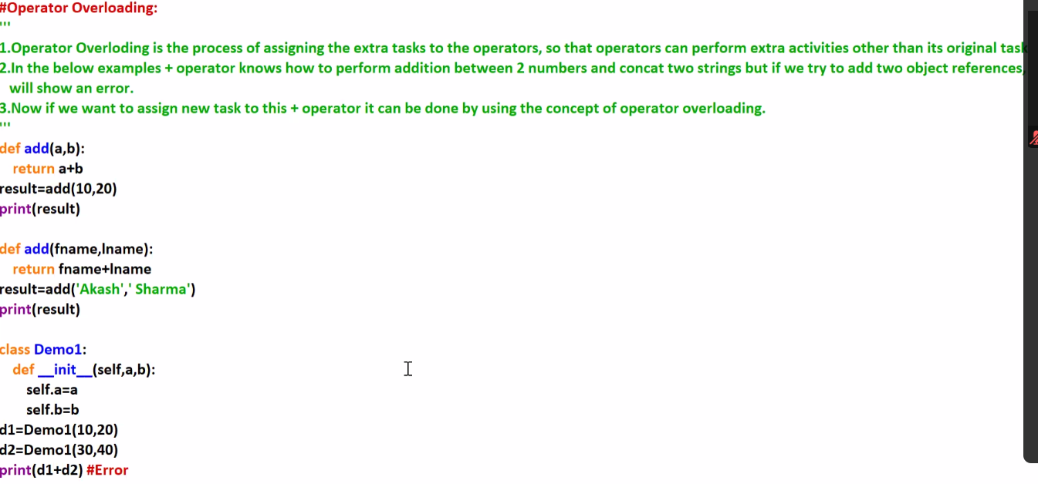

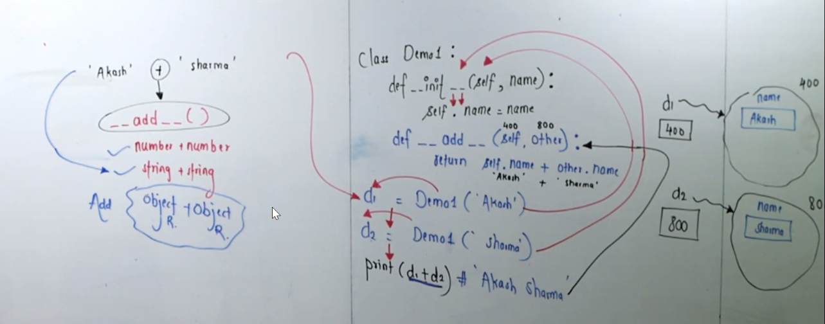

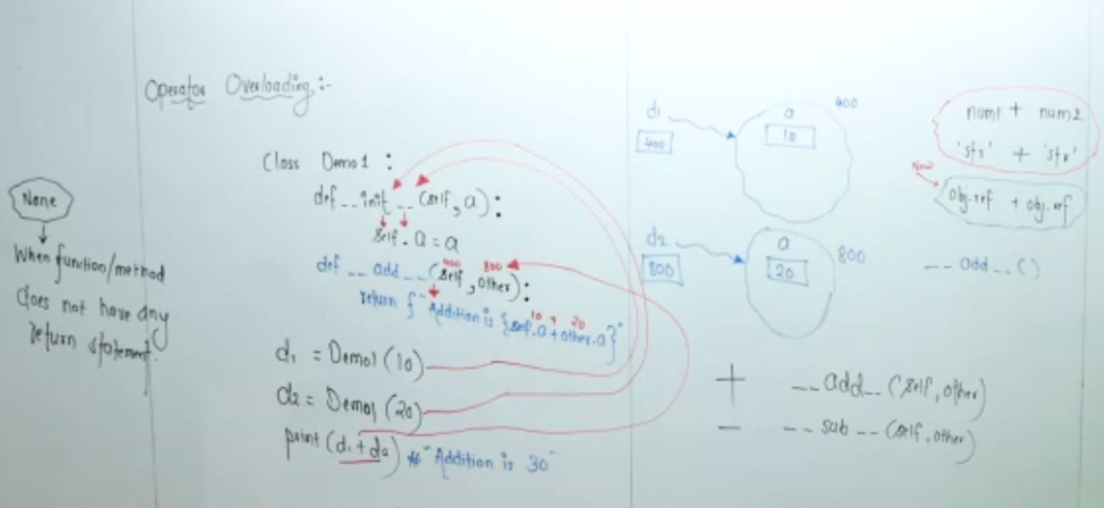

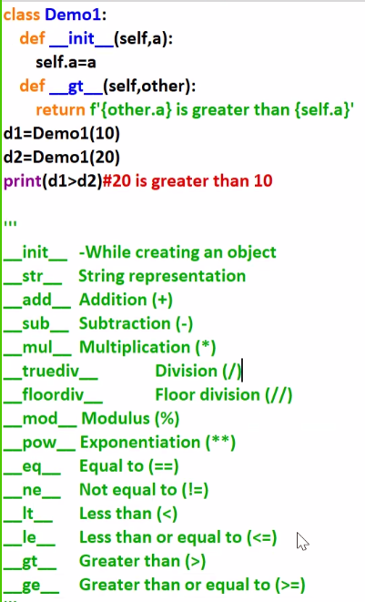

**Polimorphism:**

**Example without code compactns and code flexibility.**

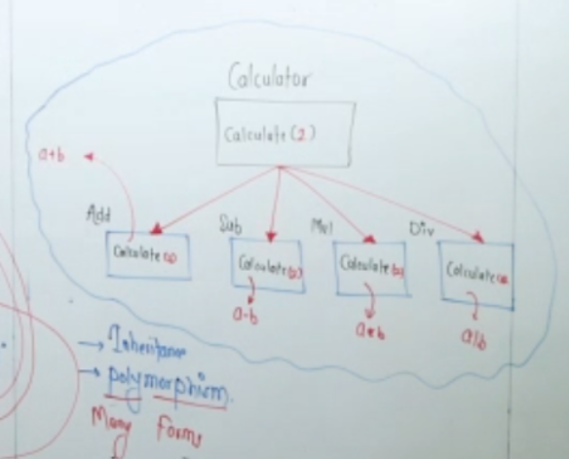

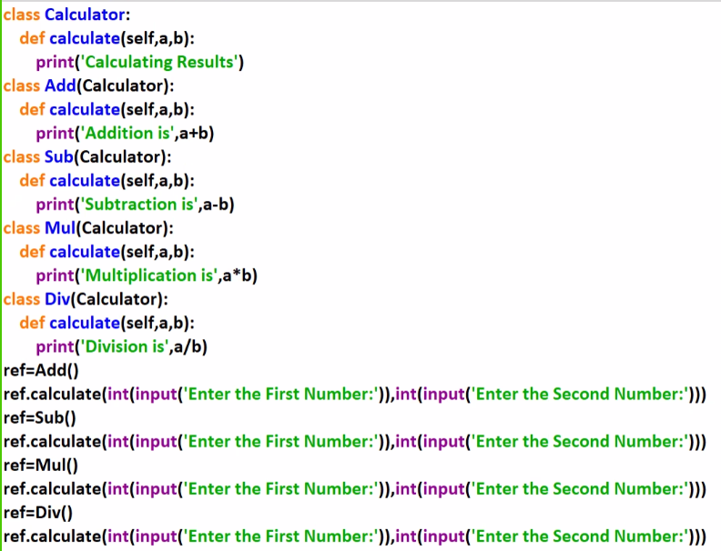

**#Abstraction in python:**

* In python if abstraction has to be achived means if a class has to be declared as abstract class then it should inherit from built in class ABC(AbstractBaseClass).
* ABC is present in module abc
* If a method has to be declared as an abstract method then a decorator @abstract method should be used on method declaration as shown below.
* In the below example game class is an abstract class and play method is an abstract method,so the obj for game class cannt be created.

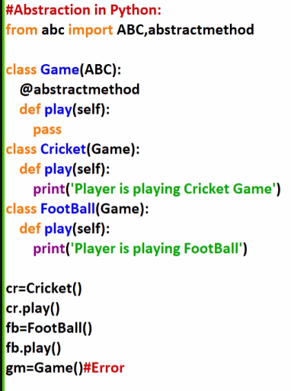

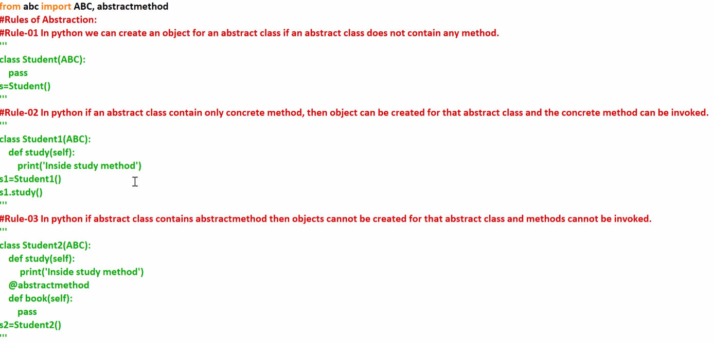Rules of abstraction:

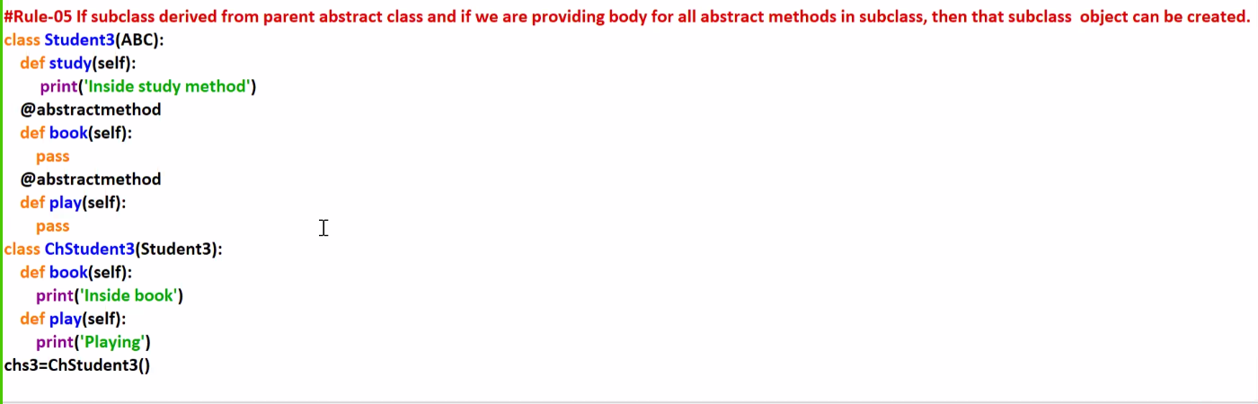

Exception Handling in python:

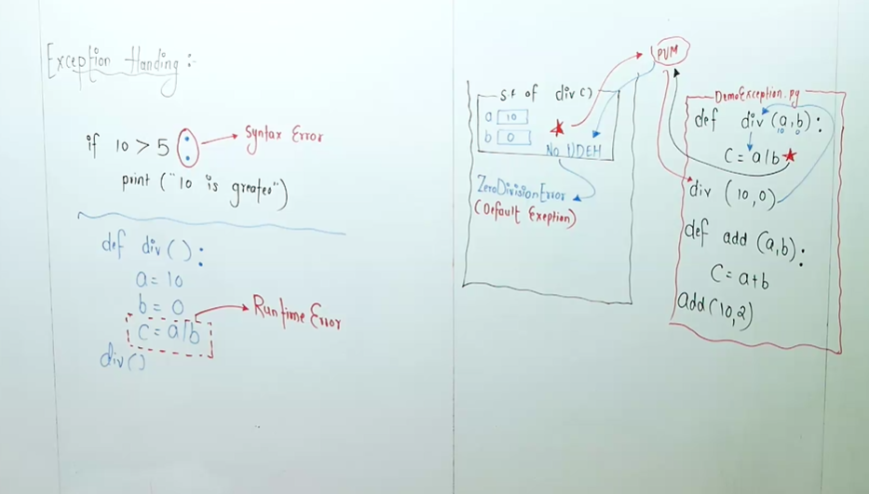

* While writing the code in python if the syntax is incorrect then CTE will be detected.
* In python program let say if the syntax is accurate but the logic is incorrect then RTE will be detected by PVM.
* When ever we are not handling the exception then the default exception will called internally.

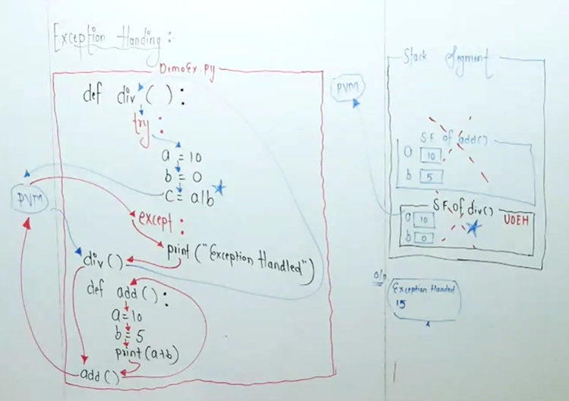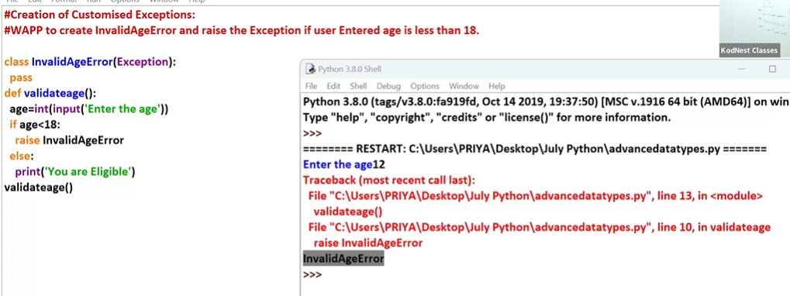

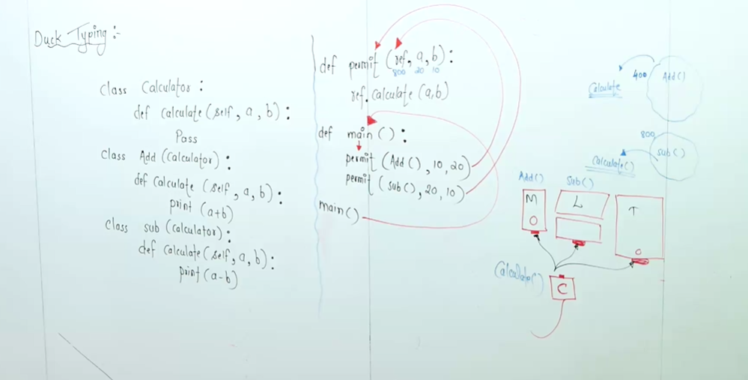

Modules:

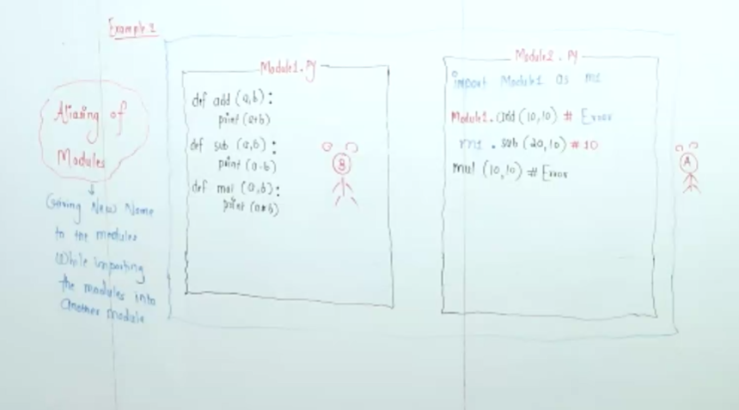

Lambda Function:

It is an ananymous Function

Syntax: lambda input:exp

Filter()

M=list(filter((lambda a:a*2),li))

Map():

li=[1,2,3,4]

sq=list(map((lambda a:a**2),li))

print(sq)

reduce():

from functools import *

li=[1,2,3,4]

sq=list(map((lambda a:a**2),li))

print(sq)

o=reduce((lambda a,b:a*b ),li)

print(o)

Decorators:

* Decorators are used to add extra functionalitiles to the methods without modifying the original implementation.

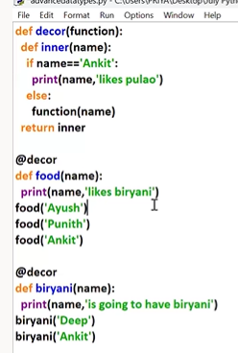

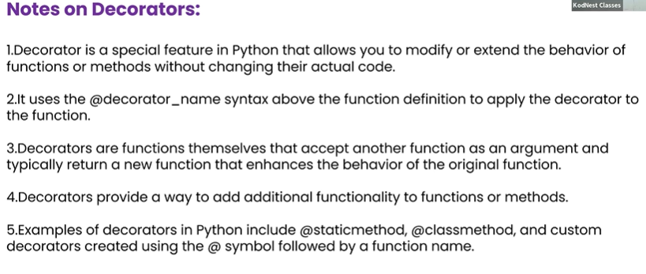

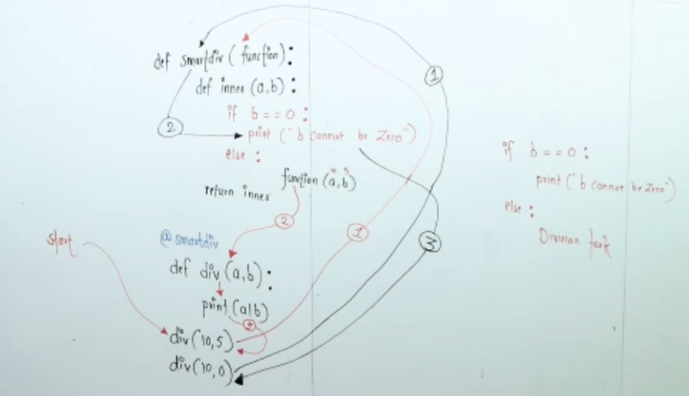

Generators:

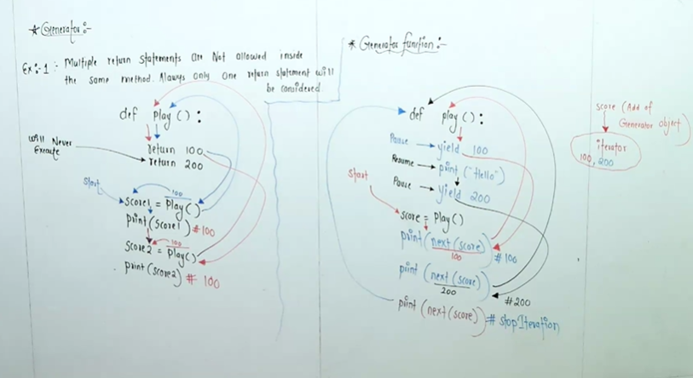

def paly():

yield 100

print("hello")

yield 200

score=paly()

print(next(score))#100

print(next(score))#hello 200

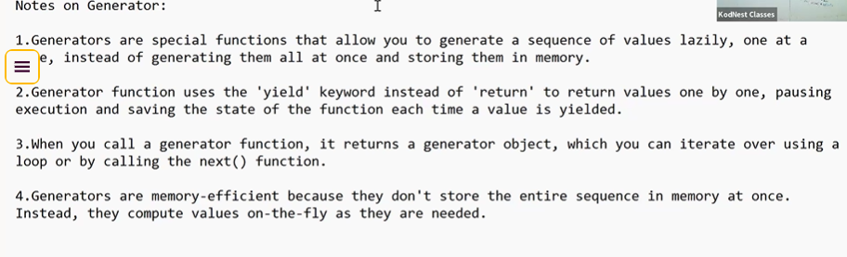

List Slicing:

To create a new list from existing list

Static In python:

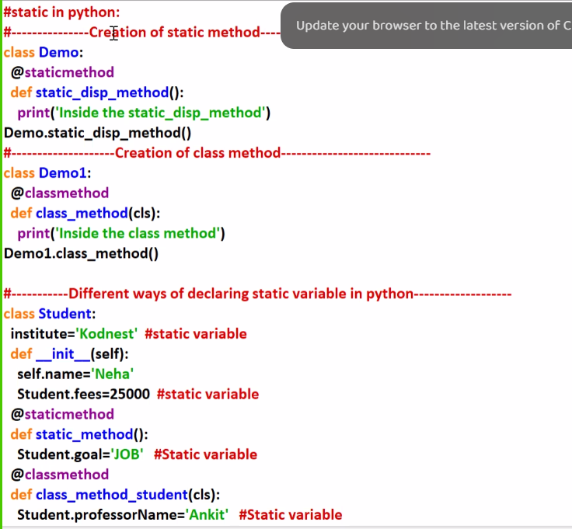

File Handling:

1. In python on files we can perform 3 operations .
   * 1. Write
     2. Read
     3. Append

Example:

#opening the file and reading the content and displaying

f1=open('text1.txt','r')

print(f1.read())

#opening the file and writing the content and displaying

f2=open('text1.txt','w')

f2.write("hello from file handling in python")

f2.close()

f3=open('text1.txt','r')

print(f3.read())

f3.close()

#opening the file and appending the content and displaying

f4=open('text1.txt','a')

f4.write(' python is amazing language')

f4.close()

f5=open('text1.txt','r')

print(f5.read())

'''coping content from file1 to file2'''

r1=open('text1.txt','r')

r2=open('text2.txt','w')

for i in r1:

r2.write(i)

r2.close()

r3=open('text2.txt','r')

print(r3.read())

**PDBC-python database connectivity**

**Pip install mysql-connector**

**Pip install mysql-connector-python**

**Pip install Django**

**Django:**

**To start new project in Django use command- django-admin startproject demopro**

**To start new app into the project first use- cd demopro**

**django-admin startapp orderfood**

**views.py-**

**views.py is a python modules that contains responsible for processing request and returning responses.**

**Each functions in views.py has a specific url pattern in urls.py**

**Urls.py-**

**Urls.py is a python module that contains urls pattern and maps to view function**

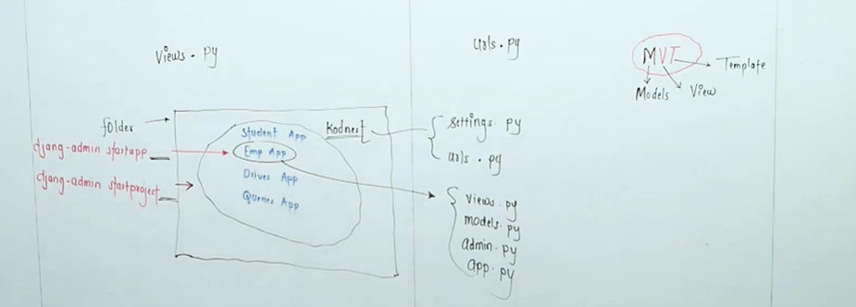

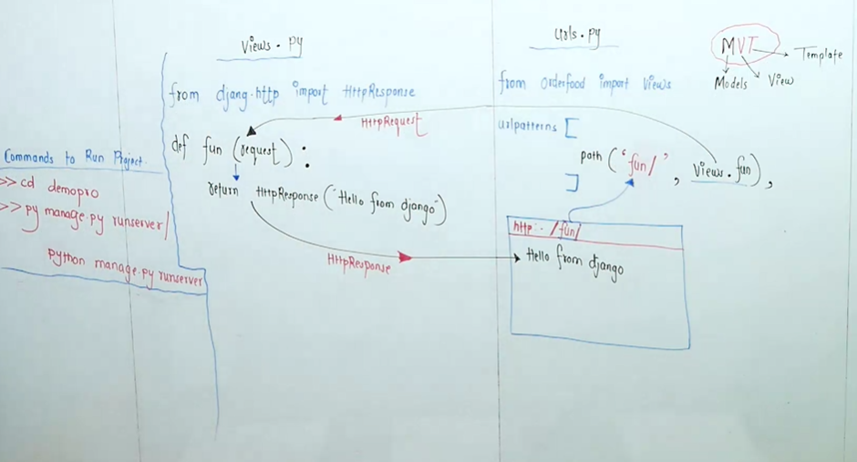

**Django-**

1. **Django is high level python web framework.**
2. **Django tries to builds websites using python.**
3. **Django comes with everything you need to create different parts of a website like storing data handling user accounts and styling of web pages.**
4. **Django MVT architecture pattern.**

**M- model V-views T-Template.**

**Model-**

**To work with databases ,model will be created using python class rather than writing sql queries directly.**

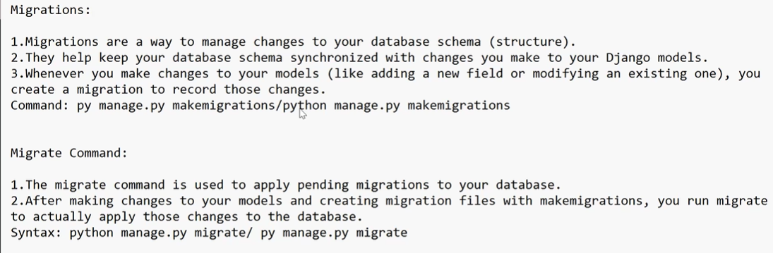

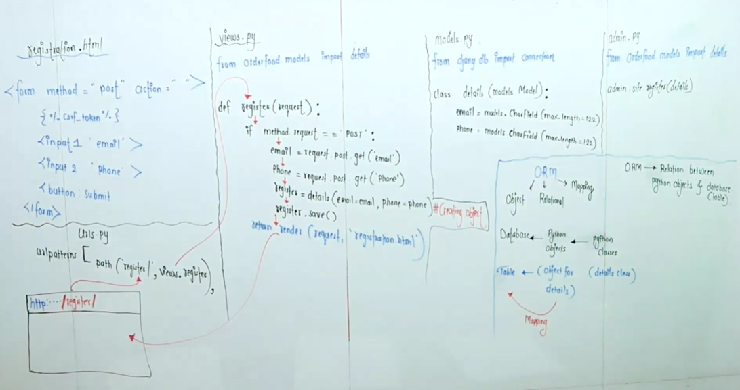

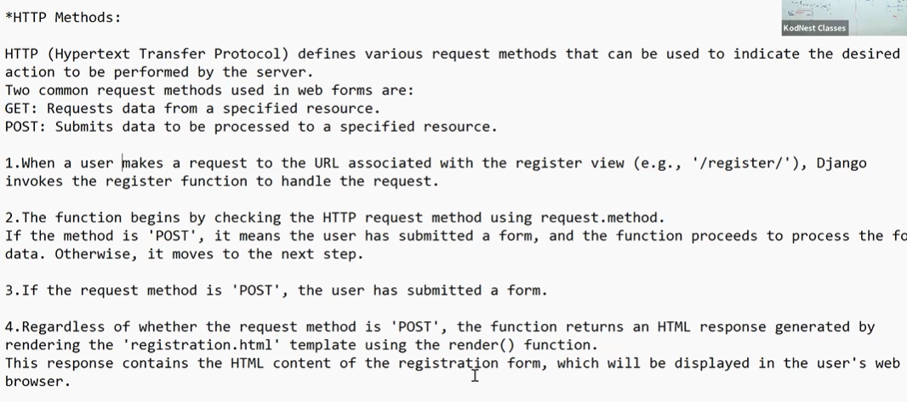

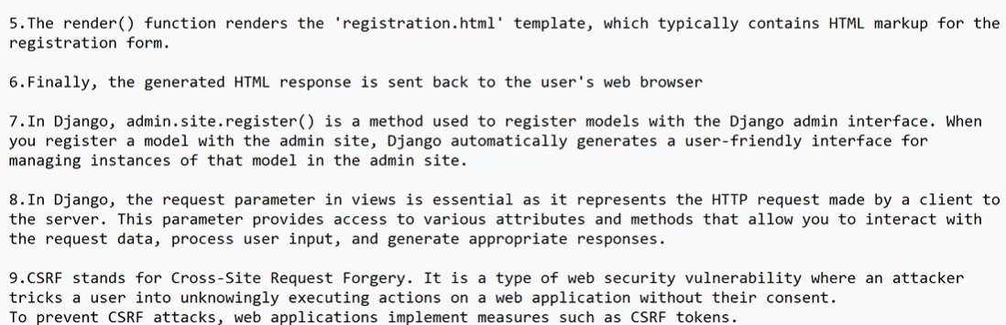

**Ecommerce app:**

**Commands:**

1. **Workon myapp**
2. **Deactivate**